Experiment: 9 Massive MIMO Capacity vs SNR and Gain Using MATLAB
Objective 1:
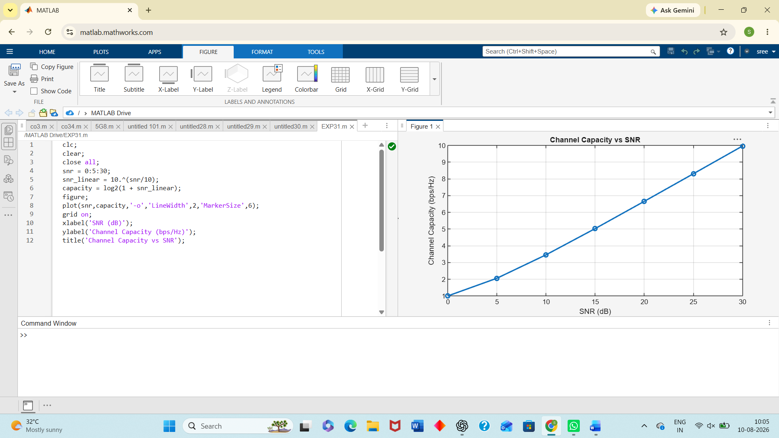
Objective 2:
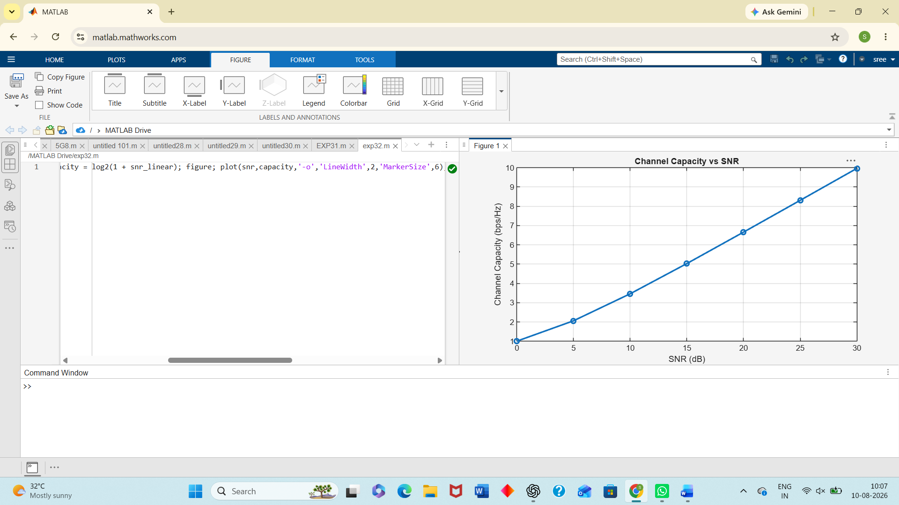
Objective 3:
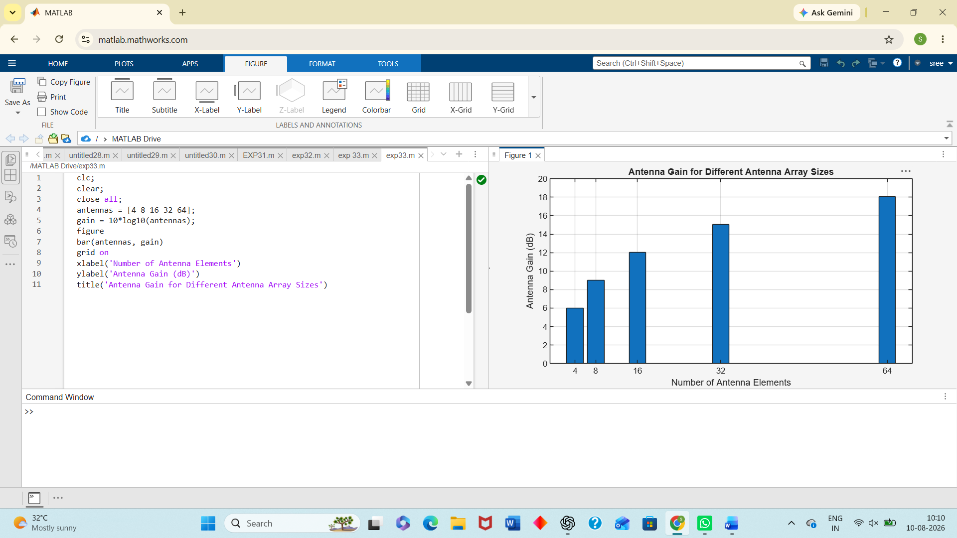
Result :
The MATLAB analysis successfully demonstrated the relationship between channel capacity, signal-to-noise ratio, and antenna gain in a Massive MIMO system. The results showed that higher SNR and larger antenna arrays improve communication performance by increasing channel capacity and directional gain.

